Robustness testing

# Flash failure

## RAM glitch

Emulate RAM glitch in flash test object in FFP:

Using map file, locate the address of `flashtest’

Use SA command as below to introduce RAM fault  
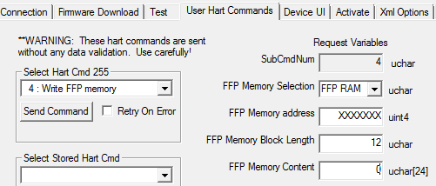

(You may need to check “Disable range checking” if you don’t want to enter all 24 zeros).

NOTE: A hex memory address must be prefixed with 0x.

Verify that the device restarts and continues

## Permanent flash failure

Similar to the above but memory content should be  
0 0 0 0 0 0 0 0 0 0 255 255

This creates a bad `flashtest’ with a valid checksum.

Verify that the device disconnects from APP (APP-owned parameters show as NULL)

Verify that the FF communications are running

Restart CPU by RB.RESTART

Verify that the device is fully functional after restart.

# Watchdog

## External watchdog

In SA “FF Diag” page, clear info:  
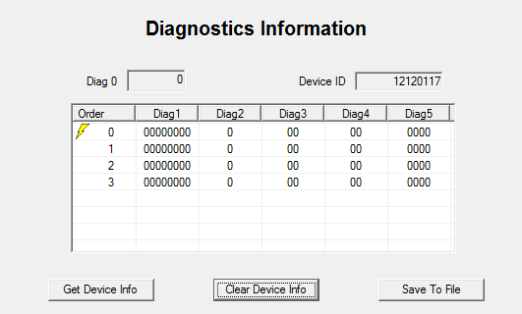

Make TB mode AUTO.

Using NI Dialog, issue RB.RESTART=30.

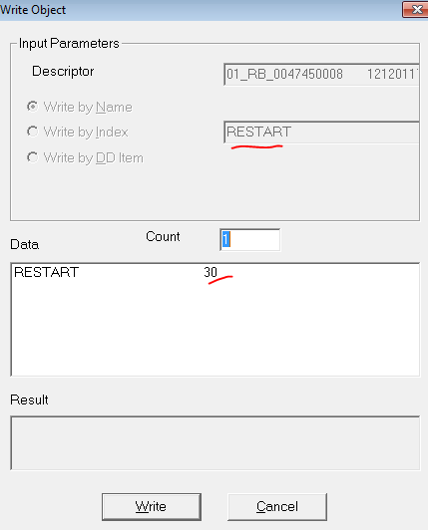

Verify that in about 3 seconds the device resets and resumes correctly. TB mode may change; record it.

Read diagnostic info again.

Verify there is an entry with Diag2=-4

## Internal watchdog

Similar but with these differences:

* RB.RESTART=31
* Verify that APP mode didn’t change
* Verify that Diagnostic info has an entry with Diag2=-8

Verify that Diag1 field is non-zero (may take several tries).   
EXPLANATION: It is a bitmap of expected and not yet completed tasks.

# Setpoint timeout

Configure TB.XD_FSTATE timeout=1 (minimum) and option= hold last value.

Without connecting AO FB (empty device), put TB in AUTO.

Reset the device.

Verify that

1. FINAL_VALUE has Uncertain status
2. Valve maintains the position for about 15-16 s
3. After that, the fault “SP LOST” is set and the valve goes to de-energized position (both AirToOpen and AirToClose)

Set FINAL_VALUE status to GOOD

Verify that valve returns under control.

Set FINAL_VALUE status to BAD.

Verify that

1. FINAL_VALUE has Uncertain status
2. Valve maintains the position for about 3-4 s
3. After that, the fault “SP LOST” is set and the valve goes to de-energized position (both AirToOpen and AirToClose)

# Network parameters

Verify that the device works correctly, including firmware update process, with these network parameters  
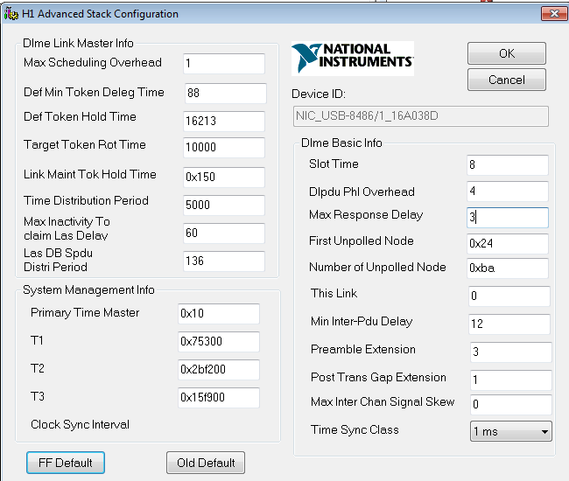

Try faster parameters (except Max Response Delay) and document results.

# NV Memory

## Reinitialization

Using SA, clear diagnostic info.

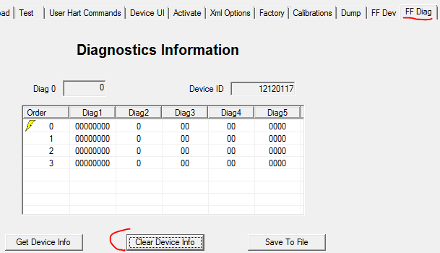

Modify some block parameters

Using NI Dialog, write RB.RESTART=169. This should reinitialize NV memory

Re-read diagnostic info.

Verify that there is a single entry with Diag2=-4 (reset)

Verify that the modified parameters reverted to their defaults.

Repeat several times with interval of at least 30 seconds.

# Instrumentation

Using the map file associated with the build, locate the address of the object `stat’ of type

struct stat_t

{

uint32_t percentCpuFree; //!< free CPU time in %

uint32_t flashRoundTripTime_min; //!< min time of full flash test in timer ticks (5 ms)

uint32_t flashRoundTripTime_max; //!< max time of full flash test in timer ticks (5 ms)

uint32_t nvmemRoundTripTime_min; //!< min time of full NVMEM test in timer ticks (5 ms)

uint32_t nvmemRoundTripTime_max; //!< max time of full NVMEM test in timer ticks (5 ms)

} stat_t;

Read these data with SA using command “read memory”

* For APP, 129.129
* For FFP, 255.3

Record the reading.

Verify that …_max values are non-zero

Clear those values using command “write memory”

* For APP, 130.129 (requires factory mode)
* For FFP, 255.4

Read these data with SA using command “read memory” again

Record the reading.

Verify that …_max values are non-zero